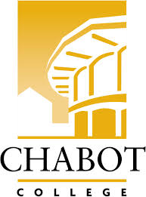
Career Education (CE Committee)
Chabot College – Zoom
Monday, February 24, 2025
12:00-1:00

AGENDA

- Welcome & Land acknowledgement – Terra
- Review and approve minutes of last meeting
- Announcements
  - Career Open House update - Robin
  - CE Events (on campus) - Terra / Kristina
    - Chabot College Career Fair - 2/27
    - Women in Manufacturing Skills Trade- 2/28
    - ROP Careers in Healthcare Day – 3/7
    - Professionals in the Legal Field Workshop – 3/14
    - CE Open House – 3/22
    - SOAR Day – 4/19
    - ECD Job Fair – 4/29
    - ROP Digital Media Day – 5/2
    - Ambulance Meet & Greet Day – 5/23
- Job Developer – John
- CE Website - Robin
- Good of the Order - Kristina
- Next Meeting 3/10/2025
- Adjournment

Mission Statement
Chabot College is a dynamic, student-centered community college that serves the educational, career, job skill, and personal development needs of our community. We provide culturally responsive, revitalizing, and sustaining learning and support services driven by a goal of equity. Building upon students’ strengths and voices, we empower students to achieve their goals and lead us towards an equitable and sustainable world.

